Notice: There are optional things to do in the game; this is just the shortened version to finish the game quicker!
- Go forward into the white room and check the table. Read the note. You can now exit the white room.
- Go left to the first room on your left and take the key from the book. You can watch a flashback if you read the name.
- Exit and go to the first room on your right. Use the key on the coffin keyhole and take the sword. Exit to the corridor.
- Go into the second room on the left. Take the Latin Dictionary and exit. You can now translate and play the Latin puzzles.
- Go back to the red text on the way. It’s on your right after you exit the white room.
- The right sequence is: The perfection of a man lies with realizing that he is not perfect.
- Go into the second room on your right. Find the white book: Il Decameron di messer Giovanni Boccaccio. Under the book, there are matches.
- Examine the Latin text to enter the second Latin puzzle.
- The right sequence is: From the depths I call upon you my Lord.
- You can exit this room and went to the third room on the right of the corridor.
- With the Latin puzzles solved, you can now find out that the painting of St. Augustine is loose. Open up and find a key and a little chest. Leave the room.
- Go to the forth room on your left in the corridor.
- Inside you will find a portrait of Jesus Christ and a big book. Take the maul and the diary and open the book. Read the inscription and take the key.
- Open up the Diary and the little chest with the keys. You will be left with a silver key.
- Use the silver key to open the third door on your right in the corridor.
- Inside there are two candles. Light them up with the matches. You can now play the organ.
- The right combination is this:
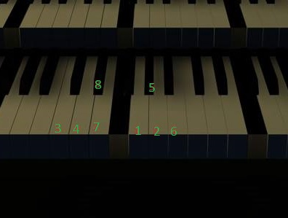
- Read the note and take the key.
- You still cannot leave the place. Go to the fifth room on your left in the corridor. Examine the wall and see that it’s built not long ago. Use the maul.
- Take the head, exit the room and use the key to the big door.
- Look down and bury the head. Put the cross so he can rest in peace.
- Walk forward and enjoy the ending.
Hint: There is a video commentary at the end. It’s the right tree…

